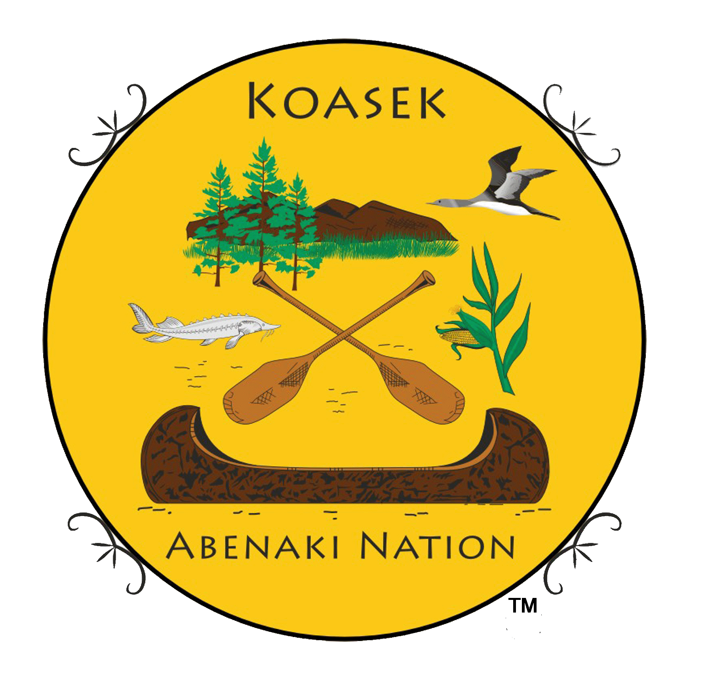

***Ko’asek (Co’wasuck) Traditional Band of the Sovereign Abenaki Nation***

***Koasek Tribe under ICCU Agreement***

***Traditional Territory of New England & Eastern Canada***

**Koasek of Turtle Island, Inc. (501/c3**

***“Preserving and restoring our native culture, while walking in peace with nature.”***

[***http://koasekabenakination.com/***](http://koasekabenakination.com/)[***https://www.facebook.com/CowasuckAbenaki***](https://www.facebook.com/CowasuckAbenaki)

***Nation Genealogist, Tribal & War Chief & Chief & Elder Paul J. Bunnell, UE*** [***Bunnellloyalist@aol.com***](mailto:Bunnellloyalist@aol.com)

***Sub-Chief & Elder Sandra DeForge, MSN, APRN*** [***smcgrath13@outlook.com***](mailto:smcgrath13@outlook.com)

***Archives & Records Center 49 Pleasant St., #106, Alstead, NH 03602***

***^^^^^^^^^^^^^^^^^^^^^^^^^^^^^^^^^^^^^^^^^^^^^^^^^^^^^^^^^^^^^^^^^^^***

***Tribal Council & Region Elder’s Council & Region***

***Jan Osgood – (Pipe Keeper) - NH Judge Karen Mica – FL***

***Dan Duhaime - NH Ruth Descoteaux – VT***

***Dr. Theresa Styles - GA (Website Master) Patrick Michaud – CT***

***Jeannine Dwyer - OR Dan Osgood Sr. – NH***

***Anne Holloway – KY Sandra DeForge, MSN, APRN - KY***

***Gigi Brakeville – WA Terri Helms - KS***

***Valerie Piedmont – NH Chief Paul Bunnell - NH***

***Mary Doonan – MA***

***Justin Deth - VT Gigi Brakeville – Shamanic Healing Practitioner***

***David Nepveu – Security/War Chief - VT***

***^^^^^^^^^^^^^^^^^^^^^^^^^^^^^^^^^^^^^^^^^^^^^^^^^^^^^^^^^^^^^^^^***

***2024 Pow Wow Committee Meeting***

***17 April 2024 at 1 PM Zoom***

***Planning for 1-2 June 2024***

***17 April 2024 Meeting 1 PM***

**Attending: Chief Paul, Maryellen Ryan-Palmer,**

**Blessing by Chief Paul**

**Meeting Leader: Maryellen Ryan-Palmer**

**Minutes by Chief Paul**

**Pow Wow Date 1-2 June 2024**

**Pow Wow Coordinator. Maryellen Ryan Palmer**

**Security – David Nepveu.**

**a. All volunteers will report to Security.**

**b. Traffic & Street Signs report to Security. Add Dogs on a leash and poop sign. Add Bridge Parking sign**

**c. Grounds Security. David Nepveu, Bob Wubbenhorst, Reb Mackenzie, Anton Angelick**

**WE NEED MORE SECURITY PEOPLE**

**Visitors/Drum/MC Comforts. MC, Tony Hay. Sacred Earth Singers, (Joseph Dunchus,** [**joedancingeagle@gmail.com**](mailto:joedancingeagle@gmail.com)**, Eric of Heavy Rain Drum Group, Spirit of the Wind, Marthe,** [**mjmdrouin@gmail.com**](mailto:mjmdrouin@gmail.com)

**Vendor Assistant – Bob Wubbenhorst Interact with them, donations, location, comfort. (Sub-Helper Deb Perry)**

**Fire Keepers – NEED HELP WITH FIRE KEEPERS 24/7. David bringing rope and posts for circle. Rick to help circle build.**

**Fire Wood: Provided by Rhonda Fowler** [**indianhollowfarm@gmail.com**](mailto:indianhollowfarm@gmail.com)

**Chief Paul will need help again to bring down and return his things. Need a truck. Possible help by Cherie and others with vans.**

**Tents For Main Areas (Total 5 Tents provided by Decker) - (Drums(1), Visitors(2), Tribal (1)), Kids Tent (1)with games. A map of the tent layout is needed for Decker on Friday. Anton can help on Friday. Nebi Waring, Dusty (Cherie), Cherie and Stephen Pernaw, Deb Perry, Rick. With Decker setting up and taking down tents all these volunteers could be use setting up Koasek vendor area or other jobs.**

**3 Toilets (1 for handicap) Ordered by Paul Best Septic VT - 802-463-9444** [**bestseptic@gmail.com**](mailto:bestseptic@gmail.com)

**Do we have ideas for trash pickup? PAUL WILL CHECK TRASH COMPANIES AND POSSIBLY LEAVING A BEN TO KEEP IT SECURED? Paul Checking Alstead Dump. Pacard & Sons P.O Box 619, Claremont, NH, 03743 (603) 542-6400**

**Candy for Candy Dance - Maryellen**

***Food Vendors to Date: Free, Donation Only***

***Orchard Hill Eleanor Elbers***

***Fry Bread (John Amil Wilder) 802-376-4772***

***Food Vendor by Bistro Autumn’s (413-663-0754*** [***sarahmiles1952@gmail.com***](mailto:sarahmiles1952@gmail.com) ***) Buffalo, Elk, Frog, hot dogs, venison etc.***

***Sharon Sweeney Shaved Hawaiian Ice,*** [***sharon@konaiceofnh.com***](mailto:sharon@konaiceofnh.com)[***www.kona-ice.com***](http://www.kona-ice.com) ***Sunday Only***

***Need More Food Vendors – Rick & Cherie checking on this***

***Vendors Vendors Please sign up now. (Free, Donation only)***

***Koasek Tribe***

***Dream Catchers by Cindy Wubbenhorst***

***Veterans Outreach Program Specialist, VOPS, Morgana Isenberg,*** [***morgana.isenberg@va.gov***](mailto:morgana.isenberg@va.gov)

***Home Base – Mark*** [***mcmoyer@mgh.harvard.edu***](mailto:mcmoyer@mgh.harvard.edu) ***617-213-1528***

***Hawk Lessard Arts Tulsa OK 918-398-3054*** [***redhawk74467@yahoo.com***](mailto:redhawk74467@yahoo.com)

***Adi-Two Owls Arts***

***NH Native American Commission***

***Sustainability Project***

***Intuitiveworks by Lisa Hutchins*** [***intuitiveworks@yahoo.com***](mailto:intuitiveworks@yahoo.com) ***HAD TO CANCEL***

***Dan Duhaime Arts & Beadworks?***

***Susan Newell Montmagny. ribbon shirts, skirts, dresses, and vests.***

***Sheila Williams Basket Making & Sales***

***Jean Schwartz Arts*** [***mezzobean@aol.com***](mailto:mezzobean@aol.com)

***Ayanna Proctor – Leather/Arts A. Proctor*** [***woodlandcrowleather@gmail.com***](mailto:woodlandcrowleather@gmail.com)

***Bob Smith Tanned Hides, Quill & Beadworks*** [***sunbursttipi@gmail.com***](mailto:sunbursttipi@gmail.com)

***Fred Lamkhorst – Silversmith*** [***tradarchers@myfairpoint.net***](mailto:tradarchers@myfairpoint.net) ***603-762-3583***

***The Traveling Workbench by Greg Collins 603-209-7710***

***Log Cabin Leather, Jan Hibbard*** [***logcabinleatherbyjan@gmail.com***](mailto:logcabinleatherbyjan@gmail.com)

***Native Creations Goods, Sherry Smiling Otter Gagne, Jessica Little Feather Penn***

***Native Creations Goods,*** [***sherry.gagne@yahoo.com***](mailto:sherry.gagne@yahoo.com)

[***https://www.facebook.com/nativecreationsgoods?mibextid=ibOpuV***](https://www.facebook.com/nativecreationsgoods?mibextid=ibOpuV)

***Pow Wow Program***

***Friday Set Up – 9AM to set up tents, and vendor areas, and move Paul items to the field.***

***Saturday - 10 AM Fire lighting & blessing***

***11:30 Smudging***

***12 Noon Grand Entry & Flag Posting & Prayer/blessing***

***12:30 Tribal Entry,***

***and Honoring to Msakkikkan Abenaki Nation (Sartigan)***

***1 PM Veteran Dance, and Public Entry***

***1:30 Contests***

***2 PM Snake Dance & Raffle (Deb)***

***2:45 Contests***

***3:30 Closing Ceremony & Flag Retrieval***

***5 PM After-hours dinner & gathering for special guest, vendors and volunteers***

***Sunday - 10 AM Blessing***

***10:30 AM Story Telling/Entertainment (On Gazebo)***

***11:30 Smudging***

***12 Noon Grand Entry & Flag Posting & Prayer/blessing***

***12:30 Tribal Entry,***

***and Honoring to Msakkikkan Abenaki Nation (Sartigan)***

***1 PM Veteran Dance, and Public Entry***

***1:30 Contests***

***2 PM Candy Dance & Raffle (Deb)***

***2:45 Contests***

***3:30 Closing Ceremony & Flag Retrieval & sleeping the sacred fire***

***After 4 PM Take down & Remove and if not we have scheduled (Need Many Volunteers for this)***

***Monday - 9 AM to Noon. Remove everything***

***Tash Pick up. Paul will find service***

***Judges***

***Cindy Wuddenhorst, Deb Perry, Maryellen, David NEED ONE MORE***

***Saturday Night Meal/Gathering: Pizzas, Donated Dishes? WHO IS BRINGING WHAT?***

***Advertising; Cindy Wuddenhorst, Deb Perry (need more)***

***Still Photos by ROBERT ARCAND*** [***robert-1c@comcast.net***](mailto:robert-1c@comcast.net) ***1 June only.***

***Pow Wow Signs: Reb Mackenzie can place signs from Charlestown to Claremont.***

***Valerie for Gilsum, to Acworth.***

***Paul ordered overflow parking sign for lot over the bridge. Need more volunteers to place and pick up signs for Alstead, Walpole, Bellows Falls, Langdon.***

***Flag Carriers (Placing & Taking down)***

***Flag Carriers American Flag***

***Canada Flag***

***POW Flag Rick Herrin***

***Koasek Flag***

***Sartigan Flag Sartigan Member***

***New Hampshire Flag***

***Quebec Flag Sartigan Member***

***Rainbow Flag***

***Acadian Flag***

***Metis Flag***

***Maine Flag***

***Vermont Flag***

***Others***

***Next Pow Wow Committee Meeting will be 17 April 2024 at 1 PM (East) Zoom. Please mark your calendars now.***

***Note: All Koasek & Tribal Friends are Invited to take part. SEND ME YOUR NAMES OF VOLUNTEERS***

***Meeting Ended:***

***Join Zoom Meeting***

[***https://us02web.zoom.us/j/6559869212?pwd=dzNqUjNnMktUeWRyNlBudmtCcDBTUT09***](https://us02web.zoom.us/j/6559869212?pwd=dzNqUjNnMktUeWRyNlBudmtCcDBTUT09)

***Meeting ID: 655 986 9212***

***Passcode: abenaki***

***Your participation in our council or committee meetings and exposure to emails or other contact lists are tribal confidential materials unless given permission by the councils. Never use unless authorized.***

**^^^^^^^^^^^^^^^^^^^^^^^^^^^^^^^^^^^^^^^^^^^^^^^^^^^^^^^^^^^^^^^^^^^^^^^^^**

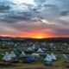 ***We are a proud supporter of the Standing Rock Lakota Sioux Tribe to the Water Protectors with***

***financial aid and nearly 1000 Berkshire Blankets in Fall of 2016***

***Our Koasek members donated financial assistance and made 200+ corona virus masks to the Navajo Nation Spring 2020.***

*** New Hampshire Charitable Foundation, Concord, NH***

***Springfield Vermont Food Co-op- Springfield VT***

***Sullivan County Conservation District, 95 County Farm Rd. Unity, NH 03743***

***Fidelity Charities, Albuquerque NH***

***Claremont Spice & Dry Goods, 12 Tremont St, Claremont, NH 03743***

***Grant Award from Maine Community Foundation, 245 Main St., Ellsworth, ME 04605***

***Henry and Helen Cormier Fund for Claremont, Special Projects Grantmaking Fund, Wellborn Ecology Fund***

***Morgan Hill Mount Cabot Maple, 69 Rowell Road, Lancaster, NH 03584***

***Quaker City Friends, Unity, NH***

***Orchard Hill Quaker (Friends), Alstead, NH***

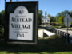 ***Alstead, NH Koasek Pow Wow 11-12 June 2022***

***Claremont Savings Bank, Claremont, NH***

***Community Village, Earth Roots Group***

***Mascoma Bank, Claremont NH***

 ***Hypertherm HOPE Foundation, Hanover, NH***

***Savings Bank of Walpole NH, Walpole, NH***

***Anonymous Donor, NH***

***Northern Lights Federal Credit Union, Langdon, NH***

***Adrianne McLaramore, Royal Oak, Michigan***

***The Orchard School and Community Center, Alstead, NH***

***Gathering Waters Chartered Public Schools (4th Grade), Keene, NH***

***Orchard Hill Breadworks, Alstead, NH***

***Sustainability Project, Gilsum, NH***

***The Center at Orchard Hill, Alstead, NH***

***The Town of Alstead, NH***

***The Ruth J. Simmons Center for the Study of Slavery and Justice at Brown University (formerly known as the Center for the Study of Slavery and Justice) and Reimagining New England Histories (RNEH)***

